

DWADA

Project Report



YAsh Sharma

23030141080

MBA IT - DA

**Problem Statement:**

**Objective:**  
Zomato, an international platform for restaurant discovery and food delivery, seeks to enhance its operational efficiency by acquiring a more profound understanding of its sales data. The objective is to examine multiple facets of customer behaviour, restaurant effectiveness, culinary preferences, and the influence of demographics on sales, with the intention of increasing customer satisfaction, strengthening restaurant collaborations, and elevating revenue.

This initiative involves an extensive examination of Zomato's food delivery sales data. The objective is to develop informative visualizations and reports that offer a more profound insight into sales performance, customer preferences, and engagement levels. The analysis seeks to identify trends, preferences, and patterns that will assist stakeholders in refining their sales strategies and improving customer satisfaction.

**Key Focus Areas:**

1. Sales Performance Evaluation:
   * 1. Examine the distribution of sales across various cities, dining establishments, and types of cuisine.
     2. Recognize the restaurants and cuisines that excel based on sales data.
2. Customer Demographics:
   * 1. Investigate how customer demographics (such as gender and income level) influence ordering behaviours.
     2. Evaluate the preferences of distinct customer segments to refine marketing approaches.
3. Cuisine and Ordering Trends:
   * 1. Identify the most favoured cuisines in different urban areas.
     2. Analyse the frequency of orders for various cuisines and categorize them (e.g., Vegetarian vs. Non-Vegetarian).
4. Restaurant Analysis:
   * 1. Pinpoint the restaurants with the highest sales figures and the most frequently ordered cuisines.
     2. Investigate the relationship between customer income levels and restaurant sales performance.
5. Temporal Trends:
   * 1. Assess sales patterns over time to pinpoint peak seasons, months, or years.
     2. Review the growth trends of restaurant sales across multiple years.

**Dataset Includes:**

* Food ->
  + - f_id
    - item
    - veg_or_non_veg
* Menu ->
  + - menu_id
    - r_id
    - f_id
    - cuisine price
* Order ->
  + - order_date
    - sales_qty
    - sales_amount
    - currency
    - user_id
    - r_id
* Restaurant ->
  + - r_id
    - name
    - city
    - rating
    - rating_count
    - cost
    - cuisine
    - lic_no
    - link
    - address menu
* Users ->
  + - user_id
    - name
    - email
    - password
    - Age
    - Gender
    - Marital Status
    - Occupation
    - Monthly Income
    - Educational Qualifications
    - Family size

**Fact Table:**

|  |  |  |
| --- | --- | --- |
| **Column** | **Data Type** | **Description** |
| Sale_ID | INT | Primary key, unique identifier for each sale. |
| Restaurant_ID | INT | Foreign key referencing the Restaurant table. |
| Cuisine_ID | INT | Foreign key referencing the Cuisine table. |
| City_ID | INT | Foreign key referencing the City table. |
| Order_ID | INT | Foreign key referencing the Order table. |
| Monthly_Income_Range_ID | INT | Foreign key referencing the MonthlyIncomeRange table. |
| Gender | VARCHAR | Gender of the customer (Male, Female). |
| Sale_Amount | DECIMAL | The amount of the sale. |
| Order_Date | DATE | Date of the order. |

**Dimension Tables:**

**1. Restaurant**

|  |  |  |
| --- | --- | --- |
| **Column** | **Data Type** | **Description** |
| Restaurant_ID | INT | Primary key, unique identifier for each restaurant. |
| Restaurant_Name | VARCHAR | Name of the restaurant. |
| City_ID | INT | Foreign key referencing the City table. |

**2. Cuisine**

|  |  |  |
| --- | --- | --- |
| **Column** | **Data Type** | **Description** |
| Cuisine_ID | INT | Primary key, unique identifier for each cuisine. |
| Cuisine_Name | VARCHAR | Name of the cuisine (e.g., Indian, Chinese). |

**3. City**

|  |  |  |
| --- | --- | --- |
| **Column** | **Data Type** | **Description** |
| City_ID | INT | Primary key, unique identifier for each city. |
| City_Name | VARCHAR | Name of the city. |
| State | VARCHAR | State or region where the city is located. |
| Country | VARCHAR | Country where the city is located. |

**4. Order**

|  |  |  |
| --- | --- | --- |
| **Column** | **Data Type** | **Description** |
| Order_ID | INT | Primary key, unique identifier for each order. |
| Order_Type | VARCHAR | Type of order (Veg, Non-Veg). |
| Quantity | INT | Quantity of items ordered. |
| Customer_ID | INT | Foreign key referencing the Customer table. |

**5. Customer**

|  |  |  |
| --- | --- | --- |
| **Column** | **Data Type** | **Description** |
| Customer_ID | INT | Primary key, unique identifier for each customer. |
| Gender | VARCHAR | Gender of the customer (Male, Female). |
| Age | INT | Age of the customer. |
| Income_Range_ID | INT | Foreign key referencing the MonthlyIncomeRange table. |

**6. Monthly Income Range**

|  |  |  |
| --- | --- | --- |
| **Column** | **Data Type** | **Description** |
| Monthly_Income_Range_ID | INT | Primary key, unique identifier for each income range. |
| Income_Range | VARCHAR | Description of income range (e.g., Below ₹10,000, ₹10,001-₹25,000). |

**7. Date**

|  |  |  |
| --- | --- | --- |
| **Column** | **Data Type** | **Description** |
| Date_ID | INT | Primary key, unique identifier for each date. |
| Order_Date | DATE | The actual date of the order. |
| Year | INT | Year part of the date. |
| Month | INT | Month part of the date. |
| Quarter | INT | Quarter of the year. |

**Entities Relationship Diagram**

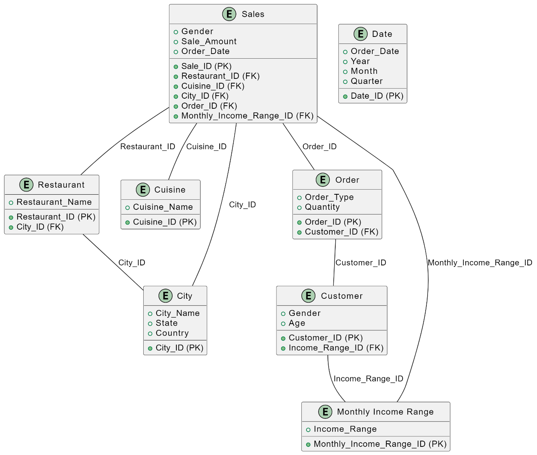

**Entities and Attributes:**

1. **Fact Table: Sales**
   * Sale_ID (Primary Key)
   * Restaurant_ID (Foreign Key)
   * Cuisine_ID (Foreign Key)
   * City_ID (Foreign Key)
   * Order_ID (Foreign Key)
   * Monthly_Income_Range_ID (Foreign Key)
   * Gender
   * Sale_Amount
   * Order_Date
2. **Dimension Tables:**
   * Restaurant
     + Restaurant_ID (Primary Key)
     + Restaurant_Name
     + City_ID (Foreign Key)
   * Cuisine
     + Cuisine_ID (Primary Key)
     + Cuisine_Name
   * City
     + City_ID (Primary Key)
     + City_Name
     + State
     + Country
   * Order
     + Order_ID (Primary Key)
     + Order_Type
     + Quantity
     + Customer_ID (Foreign Key)
   * Customer
     + Customer_ID (Primary Key)
     + Gender
     + Age
     + Income_Range_ID (Foreign Key)
   * Monthly Income Range
     + Monthly_Income_Range_ID (Primary Key)
     + Income_Range
   * Date
     + Date_ID (Primary Key)
     + Order_Date
     + Year
     + Month
     + Quarter

**Relationships:**

* Sales references Restaurant (via Restaurant_ID)
* Sales references Cuisine (via Cuisine_ID)
* Sales references City (via City_ID)
* Sales references Order (via Order_ID)
* Sales references Monthly Income Range (via Monthly_Income_Range_ID)
* Order references Customer (via Customer_ID)
* Customer references Monthly Income Range (via Income_Range_ID)
* Restaurant references City (via City_ID)

**Tableau Dashboard**

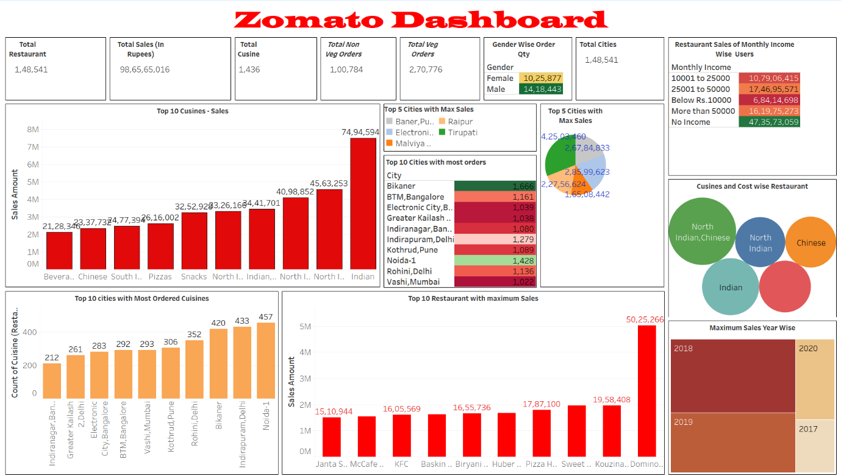

**Fig: Zomato Dashboard**

**Top-Level KPIs:**

1. **Total Restaurants:**
   * **1,48,541**: The total number of restaurants.
2. **Total Sales (In Rupees):**
   * **₹98,65,65,016**: The total sales revenue generated by the restaurants.
3. **Total Cuisine:**
   * **1,436**: The total number of different cuisines offered by the restaurants.
4. **Total Non-Veg Orders:**
   * **1,00,784**: The total number of non-vegetarian orders placed.
5. **Total Veg Orders:**
   * **2,70,776**: The total number of vegetarian orders placed.
6. **Total Cities:**
   * **1,48,541**: The number of cities included in this data, matching the total number of restaurants, likely indicating data is collected from multiple restaurants across these cities.
7. **Gender Wise Order Quantity:**
   * **Female:** 10,25,877
   * **Male:** 14,18,443
   * The data suggests that male customers have placed more orders compared to female customers.

**Graphs and Visual Insights:**

1. **Top 10 Cuisines - Sales (Bar Graph):**
   * The bar graph shows the sales revenue for the top 10 cuisines.
   * **Indian cuisine** leads with approximately ₹7.5 million in sales.
   * Other high-selling cuisines include **North Indian, Chinese, and South Indian**.
   * Beverages, snacks, pizzas, and other regional cuisines also contribute significantly.
2. **Top 5 Cities with Maximum Sales (Pie Chart):**
   * This pie chart visualizes the cities that generate the highest sales.
   * **Baner, Pune** tops the list, followed by **Raipur**, **Electronic City, Bangalore**, **Tirupati**, and **Malviya Nagar, Delhi**.
3. **Top 10 Cities with Most Orders (Heat Map):**
   * This heat map highlights the cities with the most orders, with **Bikaner** leading at 1,666 orders.
   * Other significant cities include **BTM, Bangalore** (1,161 orders), **Electronic City, Bangalore** (1,039 orders), and **Greater Kailash, Delhi** (1,038 orders).
4. **Restaurant Sales by Monthly Income (Table):**
   * This table breaks down restaurant sales by the monthly income range of users.
   * Users with an income of ₹10,001 to ₹25,000 contribute the most, followed by those earning ₹25,001 to ₹50,000.
   * Users with "No Income" still contribute a significant amount, possibly indicating students or dependent family members.
5. **Cuisines and Cost-Wise Restaurant (Bubble Chart):**
   * This bubble chart indicates the correlation between different cuisines and their average cost range.
   * Larger bubbles, like **North Indian and Chinese** or **Indian**, suggest these are popular and widely available cuisines with varied cost brackets.
6. **Top 10 Cities with Most Ordered Cuisines (Bar Graph):**
   * The bar graph lists cities with the most ordered cuisines.
   * **Noida-1** leads with 457 restaurants offering the most popular cuisine.
   * **Indirapuram, Delhi**, and **Bikaner** also show high counts, indicating significant culinary diversity.
7. **Top 10 Restaurants with Maximum Sales (Bar Graph):**
   * The graph shows the sales figures of the top 10 restaurants.
   * **Domino's** has the highest sales, followed by **Huber & Holly** and **Sweet Truth**.
   * Other notable restaurants include **McCafe**, **KFC**, and **Baskin Robbins**.
8. **Maximum Sales Year Wise (Heat Map):**
   * This heat map visualizes yearly sales data.
   * The highest sales occurred in **2020**, with **2019** also showing significant numbers.
   * This might correlate with external factors like promotions, changes in consumer behavior, or even global events.

**General Insights:**

* Indian cuisine is the most popular choice among consumers, with North Indian and Chinese cuisines also enjoying considerable sales.
* Certain cities, such as Pune and Raipur, are major contributors to these sales, reflecting a robust culture of food delivery.
* A notable portion of revenue is generated by middle-income individuals, although those without a consistent income also make a significant impact.
* Leading restaurant chains, including Domino's and McCafe, demonstrate strong sales performance, highlighting their established brand presence and customer loyalty.

**Insights from the Dashboard:**

1. **Top Cuisines by Sales:**
   1. **Indian cuisine** dominates the sales charts, with the highest sales amounting to over 7.4 million rupees.
   2. Other popular cuisines include **North Indian, Chinese, and South Indian**, each contributing significantly to the overall sales.
2. **Top Cities with Maximum Sales:**
   1. **Baner, Pune** and **Raipur** lead the sales, with Baner showing a significant margin above others.
   2. **Electronic City, Bangalore** and **Tirupati** also contribute to high sales volumes.
3. **Top Cities by Number of Orders:**
   1. **Bikaner** leads in the number of orders, followed by **BTM, Bangalore** and **Electronic City, Bangalore**.
   2. Other cities like **Greater Kailash, Indiranagar (Bangalore), and Noida-1** also show high order volumes, indicating strong customer bases.
4. **Restaurant Performance:**
   1. **Domino's** is the top restaurant in terms of sales, with over 5 million rupees in sales.
   2. Other high-performing restaurants include **Huber & Holly, Pizza Hut, and KFC**, each with substantial sales.
5. **Customer Demographics:**
   1. **Male customers** place more orders compared to female customers, with over 14 million orders from males.
   2. **Female customers** contribute significantly as well, with over 10 million orders.
6. **Monthly Income and Sales:**
   1. Customers with **no recorded income** contribute the highest sales, indicating either a large segment of customers not disclosing their income or a significant portion of sales coming from students or younger demographics.
   2. The next highest sales come from customers with a **monthly income between ₹25,001 to ₹50,000**, indicating strong purchasing power within this income range.
7. **Cuisine and Cost Relationship:**
   1. **North Indian and Chinese cuisines** are the most popular and expensive, indicating a higher demand and possibly higher average ticket sizes for these cuisines.
   2. **Indian and Chinese cuisines** also have significant customer bases but at a slightly lower price point.
8. **Yearly Sales Trends:**
   1. The highest sales occurred in **2020**, followed by **2019**, indicating a growing trend in food delivery services.

**Business Questions:**

1. How can Zomato leverage customer demographic insights to tailor marketing campaigns more effectively?
2. What strategies can be implemented to boost sales in cities with lower order volumes?
3. How can Zomato optimize restaurant partnerships, especially with high-performing restaurants?
4. What actions can be taken to encourage more orders from female customers?
5. How can Zomato use the insights from the most popular cuisines to expand its market offerings or introduce new cuisine categories?
6. What steps can be taken to sustain the sales growth observed in 2020 and previous years?